CoT for SDS vs BSR

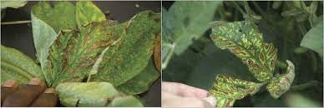
- Check growth stage and field history
  - “Are foliar symptoms appearing from early–mid reproductive (R3–R4), especially in fields with history of SDS, early planting into cool/wet soils, or SCN issues?” → Lean SDS.
  - “Are symptoms mainly mid–late reproductive (R5–R7) in cooler, moist seasons, with history of BSR?” → Lean BSR.
- Evaluate foliar symptoms
  - “Do I see interveinal chlorosis and necrosis with green veins?” → Both possible, continue.
  - “Is there rapid defoliation with petioles remaining attached to the stem?” → Strong evidence for SDS.
  - “Is yellowing/necrosis less dramatic, with fewer bare-petiole skeletons?” → Could be BSR, continue to stems.
- Force stem-splitting step (decisive fork)
  - “Split the lower stem and examine the pith vs outer tissues.”
  - “Is the pith white while outer vascular tissue/cortex is brown to gray?” → Diagnose SDS.
  - “Is the pith brown (often continuous, cardboard-like) through internodes?” → Diagnose BSR.
- Check roots and crown as supporting evidence
  - “Are roots rotted, with possible blue fungal growth or blue spore masses near the crown/taproot?” → Supports SDS.
  - “Are roots relatively sound compared to severe stem pith browning?” → Supports BSR.
- State final reasoning
  - “Because foliar symptoms plus white pith and outer vascular browning and root rot with blue growth match SDS, I classify this as Sudden Death Syndrome, not Brown Stem Rot.”
  - Or: “Because foliar symptoms plus continuous brown pith and relatively healthy roots match BSR, I classify this as Brown Stem Rot.”

CoT for IDC vs SCN
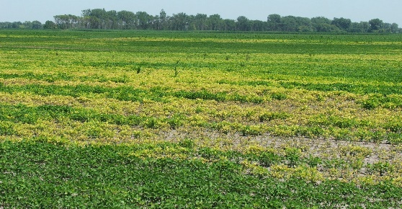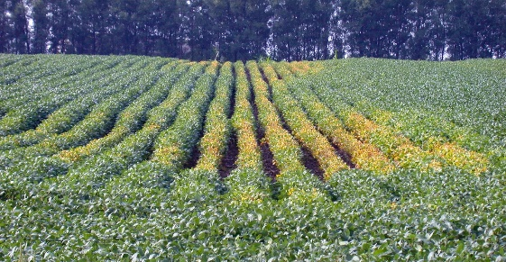

- Start from timing and site context
  - “Do symptoms appear early (V1–V3) on high-pH, calcareous, often poorly drained or saline-prone spots?” → Strongly favors IDC.
  - “Is there a known SCN history, soybean–soybean rotations, lighter soils, and symptoms possibly later or under stress?” → Raises suspicion for SCN.
- Interrogate leaf symptoms
  - “Are the youngest leaves showing clear interveinal chlorosis (yellow between veins, green veins) and sometimes necrotic margins?” → Classic IDC pattern.
  - “Is yellowing more generalized or variable, not strictly youngest leaves with sharp interveinal pattern?” → Could be SCN or other stress; continue to pattern and roots.
- Reason over field pattern
  - “Are chlorotic patches tightly associated with known high-pH / carbonate / saline zones, sometimes improving later in the season?” → Supports IDC.
  - “Are patches oval or circular, expanding or shifting slightly each year along tillage lines?” → Typical for SCN reproduction and spread.
- Roots: decisive diagnostic fork
  - “Dig plants from both chlorotic and healthy zones, wash roots.”
  - “Do I see small white to yellow lemon-shaped cysts or females on roots (mid–late season)?” → Confirms SCN.
  - “Are nodules present, roots otherwise normal to slightly stunted, with no visible cysts, and symptoms match high-pH zones?” → Supports IDC as primary issue.
- Explicit uncertainty and lab follow-up
  - “Because foliage and field pattern alone cannot definitively distinguish IDC from SCN, if cysts are not visible but SCN is suspected, I recommend a soil sample for SCN egg counts before final classification.”
  - “If soil test confirms high SCN population, SCN is a primary cause; if populations are low and soil conditions fit IDC, IDC is most likely.”

CoT: Palmer amaranth vs waterhemp (image)
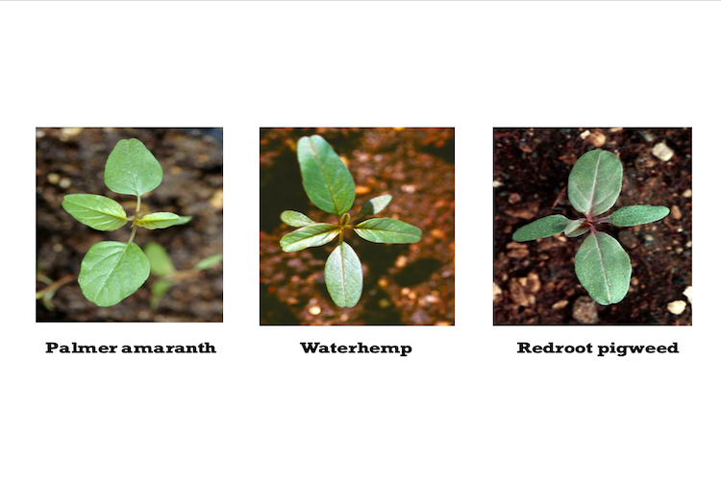
- Overall plant habit and size
  - “Is the plant tall, highly branched, with many lateral branches and a more robust, ‘tree-like’ habit?” → This leans Palmer amaranth, especially in competitive situations.
  - “Is the plant more sLook-alike,lender, with fewer, more upright branches and a somewhat more ‘willowy’ look?” → This leans waterhemp.
- Leaf shape and petiole check (key vegetative fork)
  - “Look at several mid-canopy leaves. Are they more diamond- or spade-shaped, often wider toward the tip?” → Supports Palmer.
  - “Are leaves more elongated, narrow, and lanceolate/oval?” → Supports waterhemp.
  - “Measure visually: is the petiole (leaf stalk) at least as long as or longer than the leaf blade on many leaves?”
    - Petiole ≥ leaf length on many leaves → strong evidence for Palmer amaranth.
    - Petiole clearly shorter than the leaf blade → supports waterhemp.
- Fine leaf traits the model should check
  - “Is there sometimes a single hair at the very leaf tip notch?” → When present, that tip hair is a useful clue for Palmer (not always visible).
  - “Is there a faint V-shaped watermark on some leaves?” → Can occur on Palmer but is not exclusive, so treat as a weak supporting feature only.
- Inflorescence and bracts (if flowering)
  - “Are terminal seedheads very long, thick, and tough on female plants?” → More typical of Palmer.
  - “Zoom on individual flowers on female plants: are bracts long, stiff, and extending clearly beyond the tepals, painful to the touch?”
    - Bracts 3–7 mm, stiff, extending beyond tepals → diagnostic for Palmer amaranth.
    - Bracts <3 mm, not extending much beyond tepals → consistent with waterhemp.
- CoT narrative example
  - “The plant in the image has diamond-shaped leaves with petioles as long as or longer than the blades, robust branching, and long thick seedheads with long stiff bracts, so I classify it as Palmer amaranth rather than waterhemp.”

CoT: Western corn rootworm vs cucumber beetle (striped type)
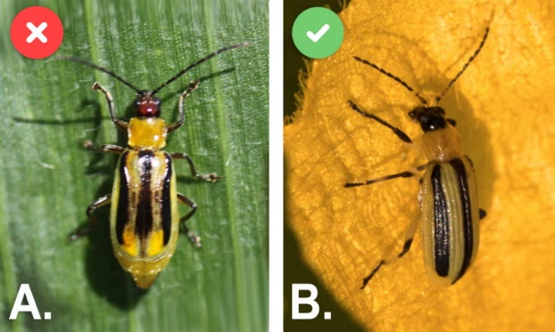
Here focus on adults that look like striped cucumber beetles.
- Confirm we are in the “striped, yellow beetle” group
  - “Does the beetle have an elongated yellow body with longitudinal dark stripes on the wing covers (elytra)?” → Both striped cucumber beetle and western corn rootworm fit; continue.
- Examine the stripe pattern on the elytra
  - “Are the three black stripes clean, narrow, and extending nearly to the tip of the elytra, with high contrast?” → These fits striped cucumber beetles.
  - “Are the stripes broader, more mottled or blurry, sometimes merging so the back looks darker overall, and do they often not extend all the way to the tip of the elytra?” → These fit the western corn rootworm.
- Check leg color (critical close-up cue)
  - “Zoom on legs: are they mostly yellow with only the joints darkened?” → Striped cucumber beetle.
  - “Are the legs entirely or almost entirely black?” → Western corn rootworm.
- Check underside color (if visible)
  - “Is the underside of the abdomen black?” → Striped cucumber beetle.
  - “Is the underside of the abdomen yellow?” → Western corn rootworm.
- Body size and overall color (supporting, not primary)
  - “Is the beetle slightly larger, often with darker overall elytra in males?” → Supports western corn rootworm.
  - “Is it slightly smaller, bright lemon-yellow with very crisp stripes?” → Supports striped cucumber beetles.
- CoT narrative example
  - “The beetle has mottled stripes that do not reach the elytra tip, all-black legs, and a yellow underside, which matches western corn rootworm rather than striped cucumber beetle.”

